Adekoniye, Adedoyin Michael
17 Babatunde Street, Agosi Estate, Ifo, Ogun State.
+2348159277099 | +2349070763392 | michaeladekoniye@gmail.com

PROFESSIONAL SUMMARY
Technically-sound Application Engineer effective in analyzing relevant information and guiding product cycle from conception to completion. Manages design effort and guides installation process for on-schedule product launches. Consults with internal and external clientele and employs additional system resources to review and enhance configuration for optimal customer satisfaction.
Self-directed and motivated Software Engineer experienced working effectively in dynamic environments. Fluent in JavaScript. .Net and PHP programming languages, including Adobe Software and Linux Systems.
SOME PROFESSIONAL CERTIFICATIONS

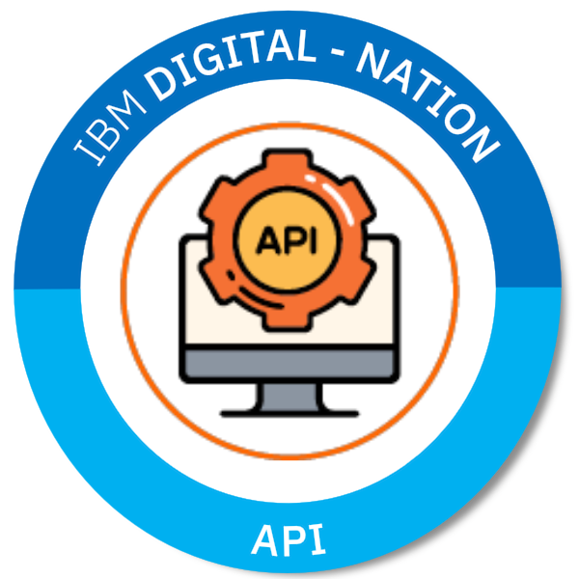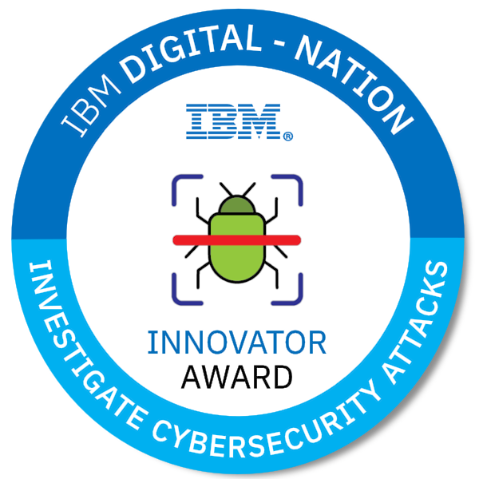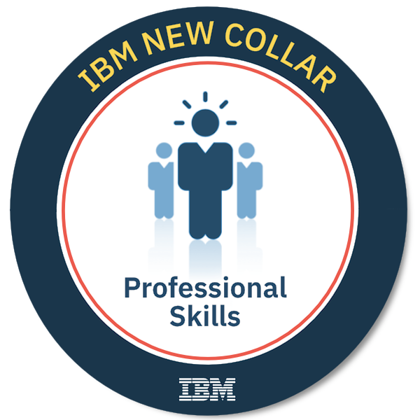

TECHNICAL PROFICIENCIES
OS Platforms: Windows XP/Vista/7/8.1/10/Server | Linux Ubuntu/Kali/Fedora
| Mac OS X.

Software: Microsoft Office | Microsoft SQL | Adobe Dreamweaver | Firebase
| Visual Studio | PhoneGap | Android Studio | GitHub | Corel Draw
| Adobe Fireworks | Adobe Photoshop | Adobe Illustrator
| Gnu Image Manipulator.

Programming Languages: Java | JavaScript | Android Java | HTML5 | CSS3 | VB | ASP .Net
| PHP | C | C++ | SQL | C# .Net.

Frameworks: jQuery.js | Service Workers | Bootstrap.css | Code Igniter
| Laravel | ASP.Net MVC Core.

API: Google Maps | Web Speech | Coin Base.

CMS: Joomla | WordPress | MyBB Forum.

PERSONAL DETAILS
Date of Birth: 9th June, 1993
Sex: Male
Marital Status: Single
State of Origin: Ogun State
Local Government: Yewa South
Nationality: Nigerian
Languages: Proficient in English and Yoruba languages.
Interests: Music, Chess, Reading, Scrabble, and Travelling.

PROFESSIONAL DEVELOPMENT

API January 2020
IBM Digital Nation Africa
https://www.youracclaim.com/badges/dd5f1b1a-3619-4fad-9724-b869e7a391a7/public_url

Web Security January 2020
IBM Digital Nation Africa
https://www.youracclaim.com/badges/ba2eab45-f0e7-4c42-bce4-3d8648bae125/public_url

Identify and Investigate Cybersecurity Threats! January 2020
IBM Digital Nation Africa
https://www.youracclaim.com/badges/1706578c-c296-4fe4-ac67-4206355fc4a3/public_url

Advance Mobile Application, Wordpress, August 2018
PHP Framework – Code Igniter/Laravel
Ultra Media Solutions
http://www.ultramediasolution.com

Android Application Development September 2017
Udacity Nanodegree Program
http://www.udacity.com

Cross Platform Application Development(Code<2>Earn) March 2016
Sponsored by: Aiki Nigeria, Google, and Microsoft.
http://bit.ly/code2earn

ASP, VB, C#, MVC Core .Net Framework May 2015
HTS Knowledge Building
Mary Land, Lagos, Nigeria.

EDUCATION
Tai Solarin University of Education, Ijagun, Ijebu-Ode. 2012 – 2016
B. Sc. (Second Class Upper Division), Computer Science.

Coker Area Comprehensive High School, Coker Area, Ifo. 2012
West African Secondary School Certificate.

Community Primary School, Agosi Estate, Ifo. 1997 – 2003
First School Leaving Certificate.

PROFESSIONAL EXPERIENCE
Schoolville Limited November 2018 – Present
Job Assignment: Full Stack .Net Web Developer, Database Admin,
Programming Instructor.

Ultra Media Solutions May 2018 – August 2018
Job Assignment: Volunteer Programming Tutor.

Independent National Electoral Commission November 2017
Anambra Gubernatorial Election
Job Assignment: Election Presiding Officer.

St. Anthony College, Enugu. (NYSC) 2016 – 2017
Job Assignment: Computer Instructor.

High Tech Synergy, Magodo, Lagos. September 2016
Job Assignment: Technical Support Staff, Database Manager.

Remo Secondary School, Sagamu. (Teaching Practice) 2015 – 2016
Job Assignment: Computer Instructor.

High Tech Synergy, Mary Land, Lagos. (SIWES) 2014 – 2015
Job Assignment: Full Stack Web Developer, Database Admin,
Programming Instructor.

TECHNICAL EXPERIENCE
No of Years of experience in IT Industry: 2012 – Present
No of Years of experience in PHP: 2013 – Present
No of Years of experience in Code Igniter: 2018 – Present
No of Years of experience in .Net Frameworks (ASP.Net, VB, C#, MVC): 2014 – Present
No of Years of experience in MySQL/MSSQL: 2013 – Present

PROFESSIONAL SKILLS
IBM Digital Nation Africa
Verified Certificate URL:
https://www.youracclaim.com/badges/2a9733a9-b068-4198-8dbf-9f59f66607a0/public_url

- Solving Problems with Critical and Creative Thinking
- Present with Purpose
- Interpersonal Skills
- Delivering Quality Work with Agility
- Collaborate Effectively
- Enterprise Design Thinking Practitioner
PERSONAL QUALITIES
Good leadership skills. | I possess excellent communication skills. | I am a highly motivated team player. | I am creative and organized. | I have the ability to gain new experiences through training.

LEADERSHIP POSITIONS
Presiding Officer November 2017
Independent National Electoral Commission

Welfare Director 2016 – 2017
Charity CDS Group (NYSC, Enugu)

REFEREES
Chief Akanji Mr. Olaleye Olayemi
Asipa House, Ilaro, Ogun State. 1, Olaleye Strt, Ifo, Ogun State.
Asipa of Ilaro Youth Coordinator (Edmac Anglican Church)
08033289345 07063621373

